SportStats Summary

**Contents**

Review of Questions to Answer/Hypotheses/Approach Discuss Technical Challenges

Detail: Entity Relationship Diagram (ERD)

Initial Findings

Deeper Analysis

Hypotheses Results

**Questions to Answer:**

Q1 - ls there any correlation between the performance of a country in Winter Olympics and that in Summer Olympics? Q2 - Does country performance by year change more in Winter Olympics or Summer Olympics?

Q3- Does country performance by year change more in Winter Olympics or Summer Olympics?

**Initial Hypotheses**

H1 -Yes

H2 -Winter Olympics

H3- Decreased

Data Analysis Approach

A1 - Calculate the Pearson correlation coefficient.

A2 - Calculate the step in country performance through years.

A3 - Draw a simple histogram.

**ERD**

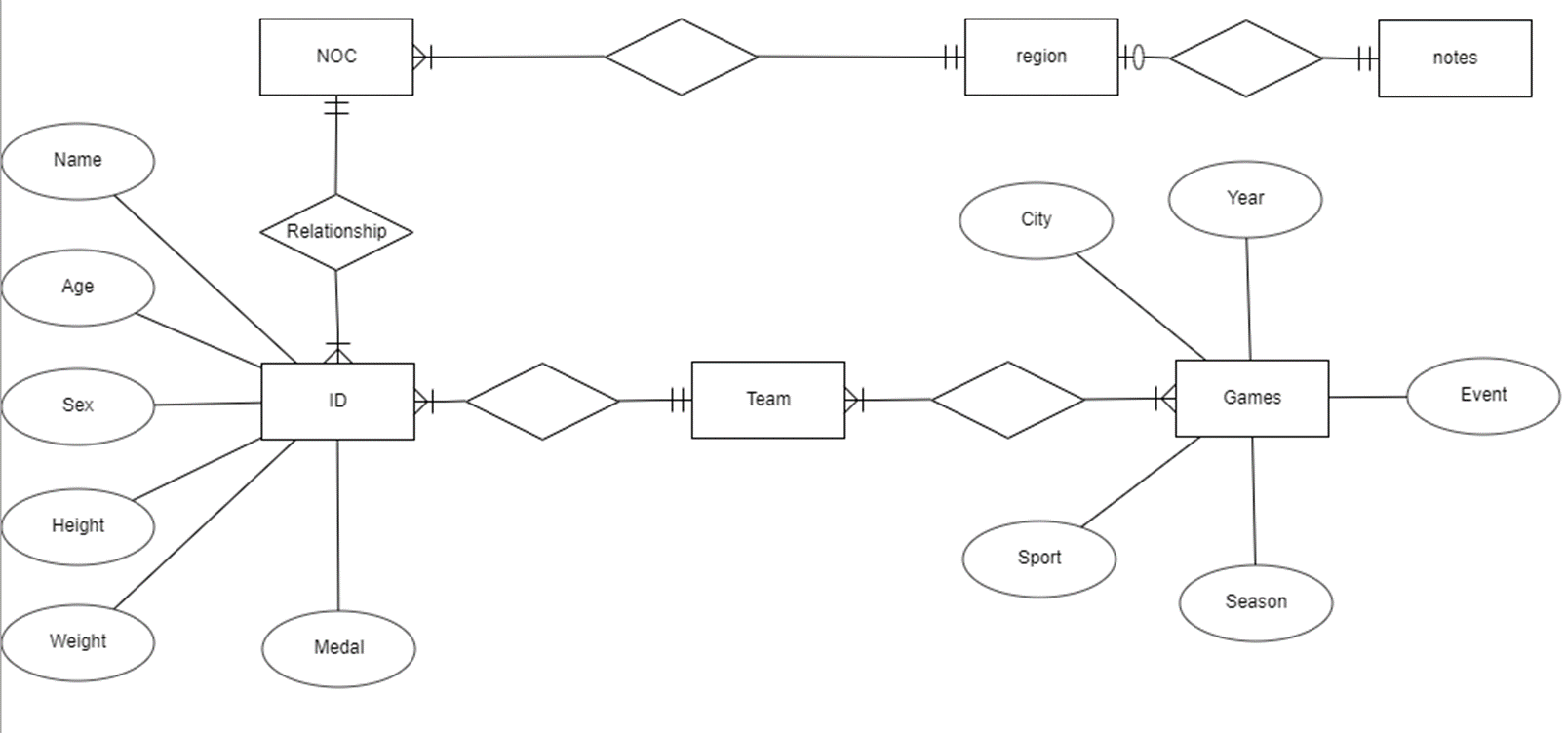

**Initial Findings**

In the last century, the medal ratio fluctuated greatly in the two competitions, but eventually stabilized. This can be interpreted as establishing norms on these issues.

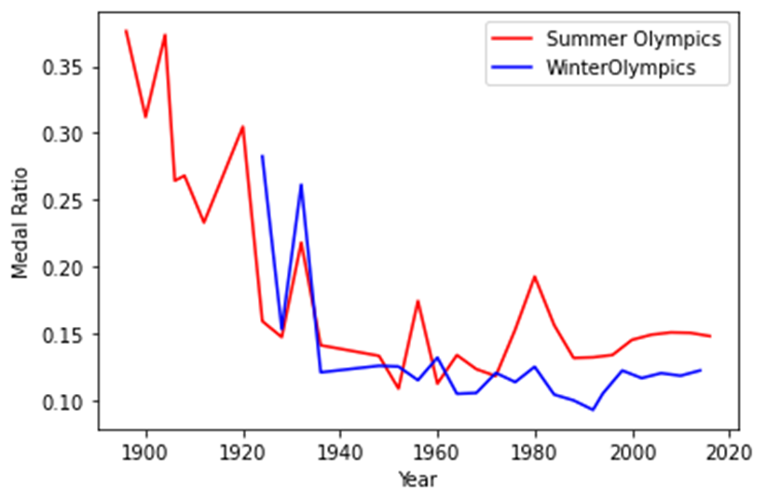

The relative percentages of gold, silver and bronze medals have also stabilized, which may be due to the reasons mentioned above.

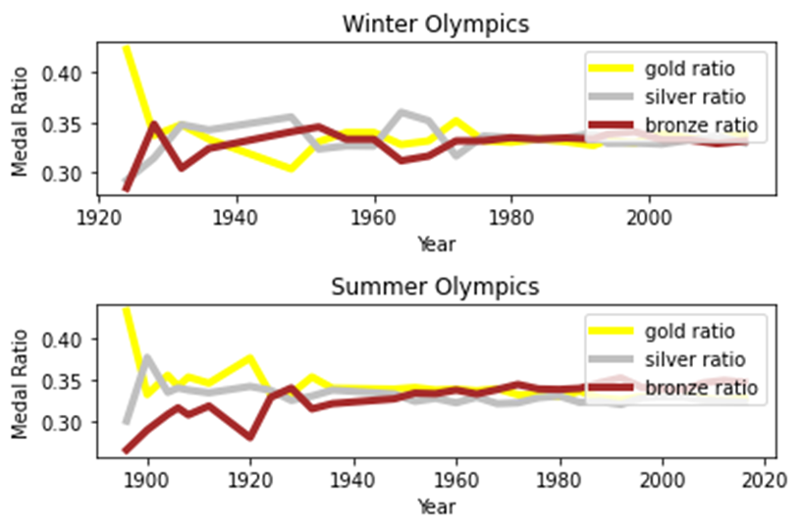

This assumption seems to be correct. Over time, the ratio of women to men has indeed increased. However, there is an interesting detail: during the Second World War, the proportion of the Summer Olympics dropped sharply, but then it resumed its growth momentum. Without further analysis, I cannot explain this phenomenon.

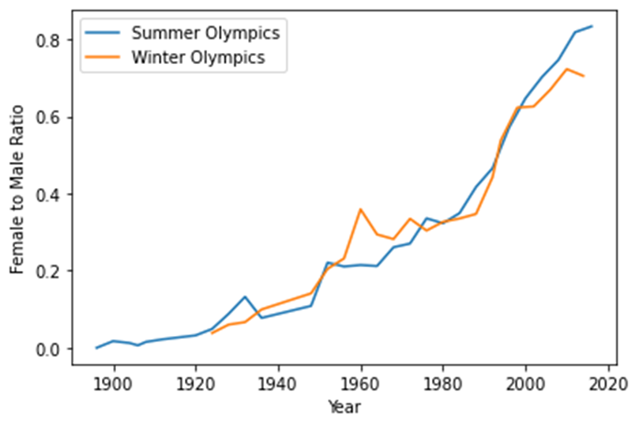

Deeper Analysis

The length of the array of the number of medal count in the winter Olympics and summer Olympics are different because Winter Olympics started in 1924, but Summer Olympics started in 1896. Therefore, l have to create a new shortened table of the summer Olympics started in 1924 to match the length of the winter Olympics.

**Final Findings**

The performance of a country in Winter Olympics is highly correlated to that in Summer Olympics.

The country performance by year change more in Winter Olympics than that in Summer Olympics.

The male: female ratio has decreased from 1896 to 2016.